IR SENSOR : electronic device, that emits the light in order to sense some object of the surroundings.

Working process :

1. IR transmitter : Infrared Transmitter is a light emitting diode (LED) which emits infrared radiations called as IR LED’s. Even though an IR LED looks like a normal LED, the radiation emitted by it is invisible to the human. 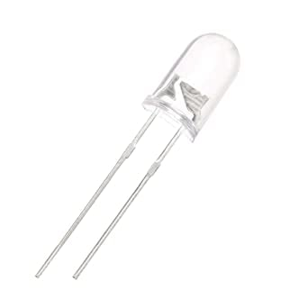
2. **IR Receiver :**  detect the radiation from an IR transmitter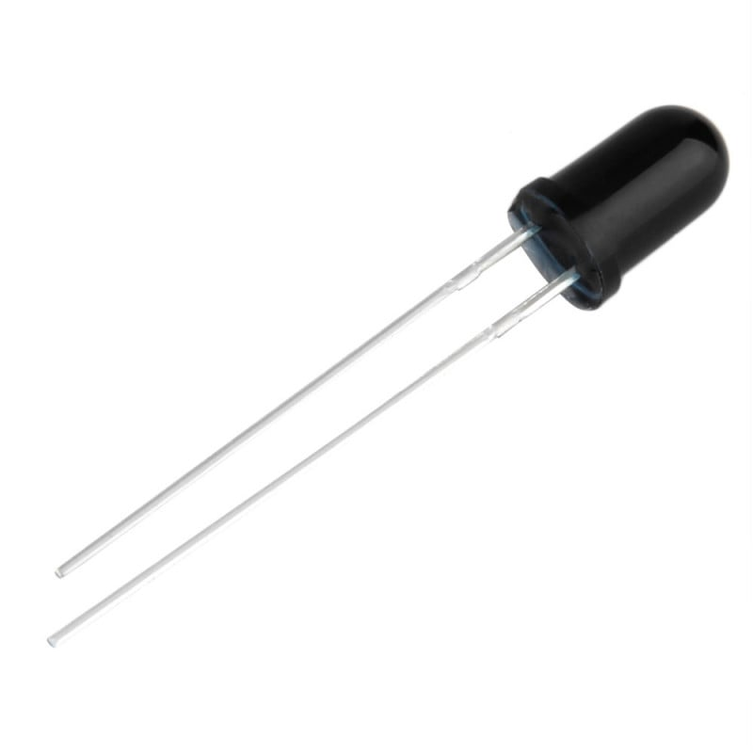
3. 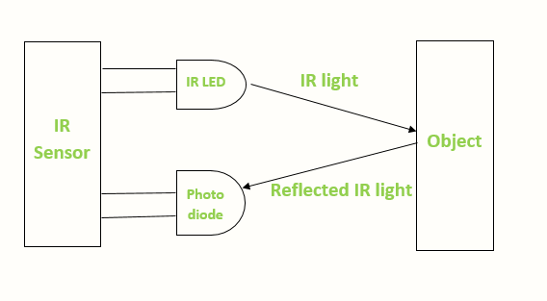

Active infrared sensors both emit and detect infrared radiation. Active IR sensors have two parts: a light emitting diode (LED) and a receiver. When an object comes close to the sensor, the infrared light from the LED reflects off of the object and is detected by the receiver.

[What is an IR sensor? | Fierce Electronics](https://www.fierceelectronics.com/sensors/what-ir-sensor#:~:text=Active%20infrared%20sensors%20both%20emit,is%20detected%20by%20the%20receiver.)

[IR sensor Working Principle and Applications | Robu.in](https://robu.in/ir-sensor-working/)